Image | 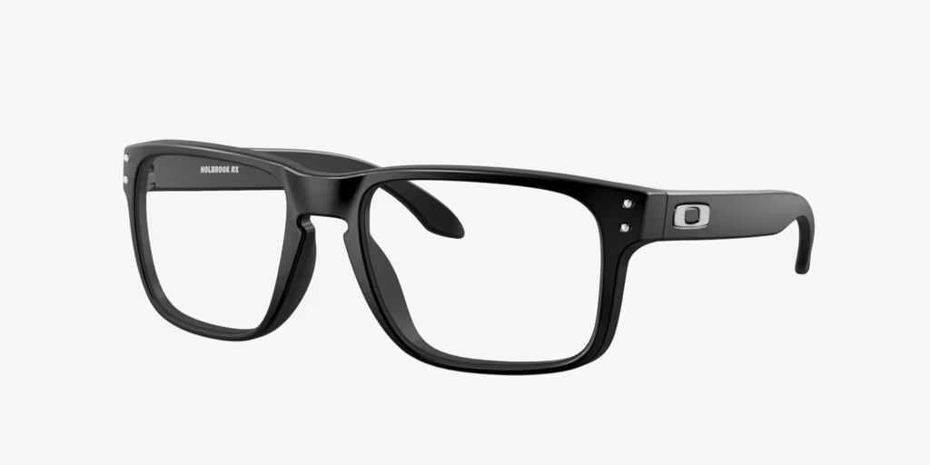
Brand | MICHEAL KORS
Model Name | OX8156 HOLBROOK
Price | RS 2500
PRODUCT DETAILS

